Alyn Hospital

Gait Visualization System

User manual

Introduction
There is a need for developing a video system which will help mechanotherapists to analyze the gait of young patients in Alyn Children Rehabilitation hospital.
The Gait Visualization System is a video system based on multiple cameras, to be used in a dedicated room. The patient is instructed to walk a few meters in the room, while a set of synchronized cameras records his motion through the room. The resulting video clips are then simultaneously displayed on a common computer screen, so the mechanotherapists can review and diagnose the details of the patient's body movements.

General Architecture
The proposed system consists of at least three video cameras (shutter visual sensors). Two of the cameras are lateral, one is frontal. Each camera is controlled by a single-board computer (SBC) RaspberryPi 4. Each camera records a single video stream and stores it in local storage of the corresponding SBC. The cameras are interconnected through a standard Ethernet network. A dedicated PC reads the video streams and displays them contiguously on screen.
See the diagram below:
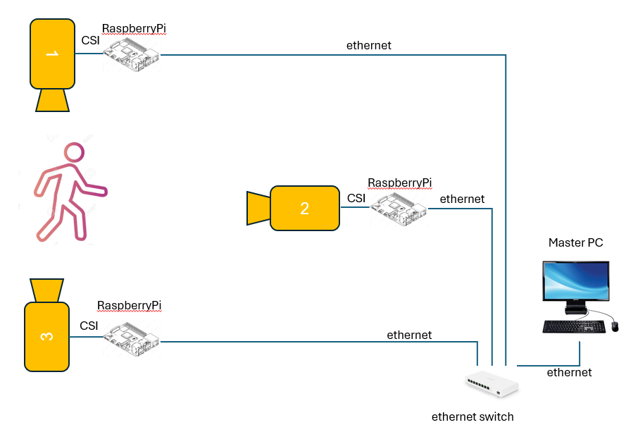

Functionality
There are 4 functionality modes.

Setup Mode
In this mode, the Master Pc is used to develop and upload software into the RaspberryPi SBCs. The communication is through standard tools such as RealVNC for remote control and FileZilla for file upload/download.

Initialization Mode
In Initialization mode, the cameras are activated and the resulting video streams are forwarded in real time to the Master PC and displayed on the screen. This allows physical alignment of the cameras to the correct position and tilt, pan.

Recording Mode
In Recording mode, the Master PC sends a command to the SBCs, consisting of start time and duration of the recording (assuming SBCs and Master PC are synchronized using RTP). Following the command, the cameras are simultaneously activated, and the resulting video streams are stored into local memory (SD card, or SSD). Another command can be used to stop recording.

Analyze mode
In Analyze mode, the recorded streams are uploaded to the Master PC for analysis. This can be done through storage sharing between the SBCs and Master Pc.

Setup

5.1 OS
Install OS on SD card to obtain:
PRETTY_NAME="Debian GNU/Linux 13 (trixie)"
NAME="Debian GNU/Linux"
VERSION_ID="13"
VERSION="13 (trixie)"
Then upgrade all:
sudo apt upgrade

Have one user:
Username: alyn
Password: alyn

SMB
Note: samba is not reliable. We use ssh instead.
Install Samba:
sudo apt install samba samba-common-bin -y

make a shared directory:
mkdir videos

modify /etc/samba/smb.conf, by adding at the end:
[videos]
comment = Raspberry Pi Shared Folder
path = /home/alyn/videos
browseable = yes
writeable = yes
only guest = no
create mask = 0777
directory mask = 0777
public = no
valid users = alyn
force user = alyn

then

sudo smbpasswd -a alyn
sudo systemctl restart smbd
sudo systemctl status smbd

Note:
On PC, login to each rpi in Windows browser, by login to:
\\192.168.50.11(/12/13/14)\videos: user – alyn, password: alyn, and keep login got later use.

LAN setting

Use Tftpd64 tool to set DHCP as follows (FIXME)
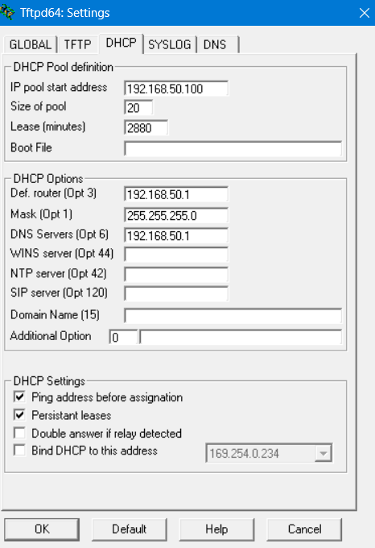

RPI configuration

Disable WAN and enable ethernet as follows:
Assign fixed and known IP to each Raspberry Pi ethernet:
sudo nmtui
Edit a connection
→ Wired connection 1
IPv4 CONFIGURATION
→ Manual
Field | Value
Address | 192.168.50.11(or 12 or 13 or 14 respectively)/24
Gateway | empty
Optional DNS:
8.8.8.8
Then on PC:
Login to each rpi in Windows browser, by login to:
\\192.168.50.11(/12/13/14)\videos: user – alyn, password: alyn, and keep login got later use.

5.5 Raspberry Pi Synchronization
Install chrony on rpi:
sudo apt install chrony -y
sudo nano /etc/chrony/chrony.conf
Add near top:
server 192.168.50.1 iburst
Enable NTP server on PC:
On PowerShell:
Set-Service w32time -StartupType Automatic
Start-Service w32time
On Admin CMD:
reg add HKLM\SYSTEM\CurrentControlSet\Services\W32Time\TimeProviders\NtpServer /v Enabled /t REG_DWORD /d 1 /f
reg add HKLM\SYSTEM\CurrentControlSet\Services\W32Time\Config /v AnnounceFlags /t REG_DWORD /d 5 /f
on PowerShell:
New-NetFirewallRule -DisplayName "NTP Server UDP 123" -Direction Inbound -Protocol UDP -LocalPort 123 -Action Allow -Profile Private
On admin CMD:
Restart-Service w32time
w32tm /resync

Install synchronization service
On RPI:
Synchronization is based on sync_clock.py script.
Sync_clock.py is activated at boot by
/etc/systemd/system/syn_clock.service script with the following content:

[Unit]
Description=Synchronize Pi clock with Windows PC
Wants=network-online.target
After=network-online.target

[Service]
Type=simple
User=root
ExecStart=/usr/bin/python3 -u /home/alyn/gait/sync_clock.py
Restart=always
RestartSec=5

[Install]
WantedBy=multi-user.target

To run the service type the following:
sudo systemctl daemon-reload
sudo systemctl enable --now sync-clock.service

On PC
First go to gait directory
cd C:\Users\<user>\OneDrive\מסמכים\Alyn\gait analysis
Then run the sync service:
python3 time_server.py

Install ffmpeg in PC
Winget install ffmpeg

Automatic Rpi start
Create a service named gait-video:
sudo nano /etc/systemd/system/gait-video.service

The content of the file is:
[Unit]
Description=gait camera Service
After=network.target
[Service]
ExecStart=/usr/bin/python3 /home/alyn/gait/capture_StreamVideo.py
WorkingDirectory=/home/alyn/gait
StandardOutput=inherit
StandardError=inherit
Restart=always
User=alyn
[Install]
WantedBy=multi-user.target
Then run:
sudo systemctl daemon-reload
sudo systemctl enable gait-video.service
sudo systemctl start gait-video.service

SSH initialization
On Windows
Generate a key:
ssh-keygen
Press Enter for all prompts.
This creates:
C:\Users\<username>\.ssh\id_rsa
C:\Users\<username>\.ssh\id_rsa.pub
(or id_ed25519 on newer systems)
Copy the public key to the Pi
Run:
ssh-copy-id alyn@192.168.1.101
If ssh-copy-id isn't available on Windows:
type $env:USERPROFILE\.ssh\id_ed25519.pub
Copy the contents.
Then on the Pi:
mkdir -p ~/.ssh
nano ~/.ssh/authorized_keys
Paste the key and save.
Set permissions:
chmod 700 ~/.ssh
chmod 600 ~/.ssh/authorized_keys
Now test:
ssh alyn@192.168.1.101
You should log in without a password.
Then:
scp alyn@192.168.1.101:/home/alyn/videos/video.mp4 .
will also work without a password.
You can use the same key pair for all of your Raspberry Pis, and that's actually the most common approach.
Recommended setup
On your Windows PC:
ssh-keygen -t ed25519
This creates:
C:\Users\<your_user>\.ssh\id_ed25519
C:\Users\<your_user>\.ssh\id_ed25519.pub
Then copy the same public key (id_ed25519.pub) into:
/home/alyn/.ssh/authorized_keys
on each Raspberry Pi.
Result:
Windows PC
│
├── SSH key
│
├── RPi #1
├── RPi #2
├── RPi #3
└── RPi #4
One key can authenticate to all of them.
4. Check SSH server config on Pi
sudo grep -E "PubkeyAuthentication|AuthorizedKeysFile|PasswordAuthentication" /etc/ssh/sshd_config
You want at least:
PubkeyAuthentication yes
AuthorizedKeysFile .ssh/authorized_keys
Then restart SSH:
sudo systemctl restart ssh
Most common fix:
chmod 700 /home/alyn/.ssh
chmod 600 /home/alyn/.ssh/authorized_keys
chown -R alyn:alyn /home/alyn/.ssh

Improvements
- Guidance for users: כיול, גובה המצלמות, זווית, פוקוס, זום
- סווג של סרטונים עם מס' תיק, תאריך, מצב מתועד
- Start/stop for capture
- Automatic display
- Serial number per file
- Folder for date, subfolder for file number
- FPS = 50

Notes
- Rpi1 is replaced by rpi5
- NTP source of rpi5 is rpi4, not PC.

Improvements
- Frame rate: is it correct?
- GUI

